Name: Sadia Barkat

Roll No: 131214

Day 4: Building Dynamic Frontend Components for Marketplace.

Introduction:

Its hackathon 3 and my template was 4 in which furniture items was present. “Hekto” is my brand name and it contains all the items used as furniture.

In this website, I used Sanity to show product list.React hooks like{useEffect, useState} are also being used.

1.Product listing component:

\*I build dynamic frontend components to display data from Sanity CMS or APIs.

\*Screenshot contains

-Product name

-Price

-Image

-Stock status

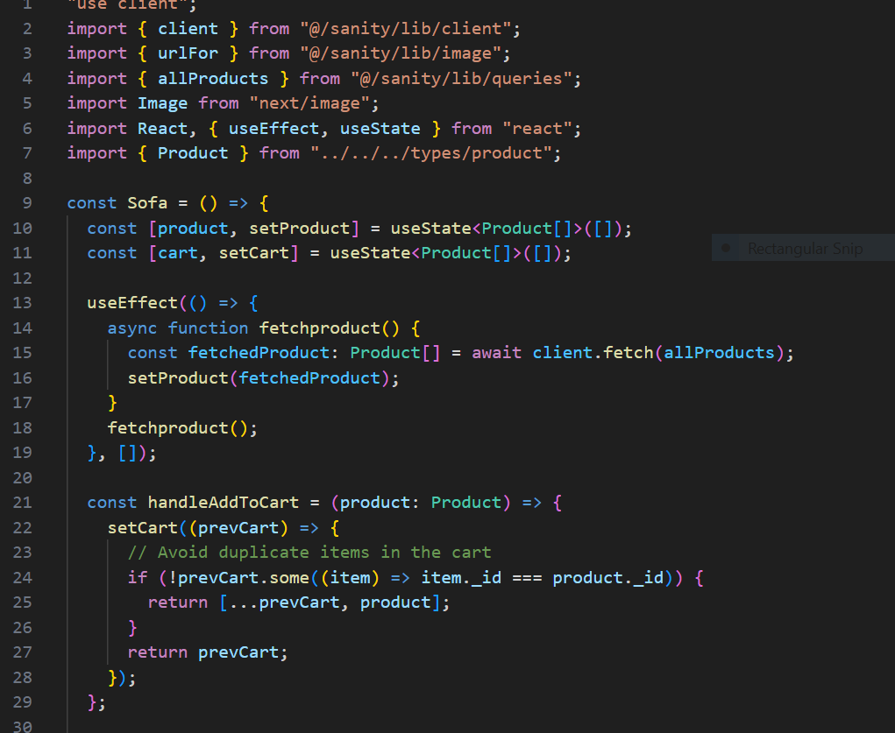

Screenshot contains coding of fetch product.

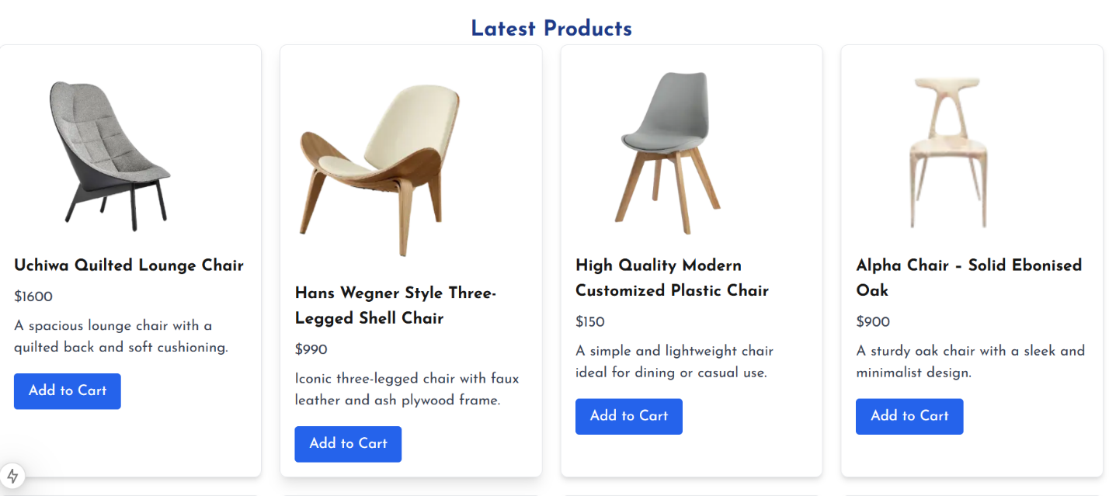

2.Add to Cart Component:

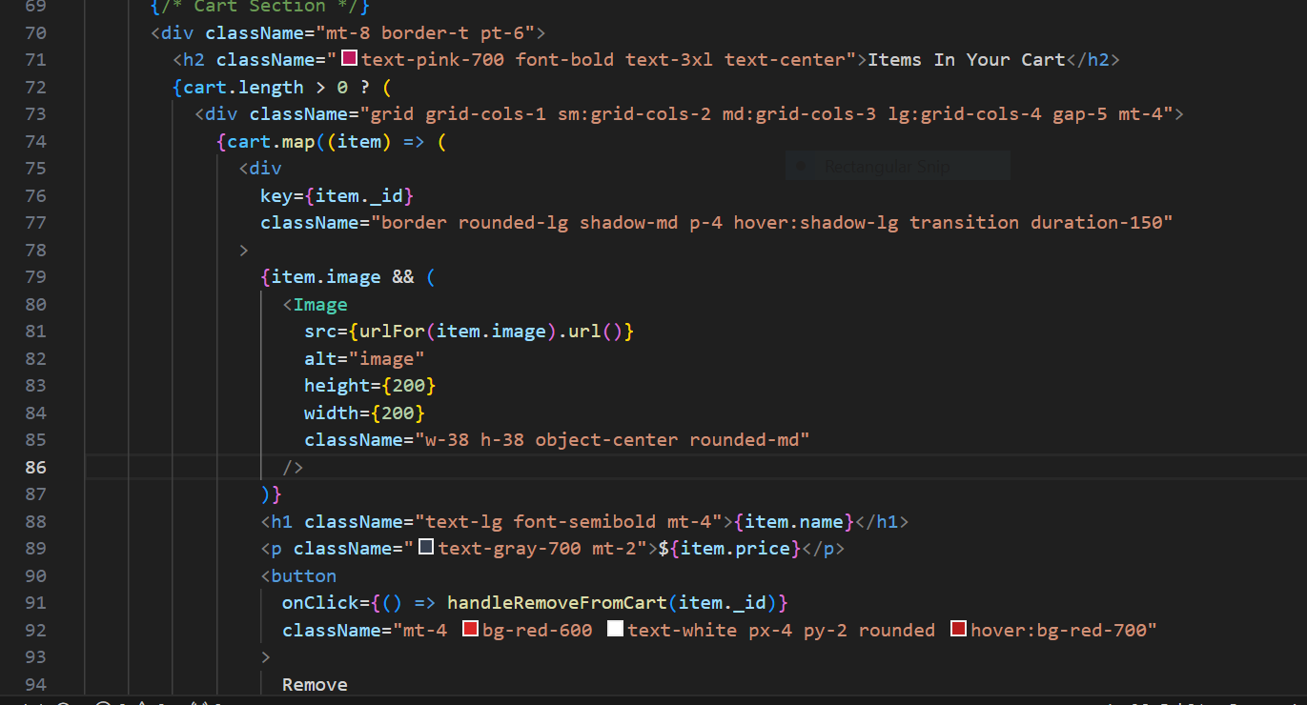

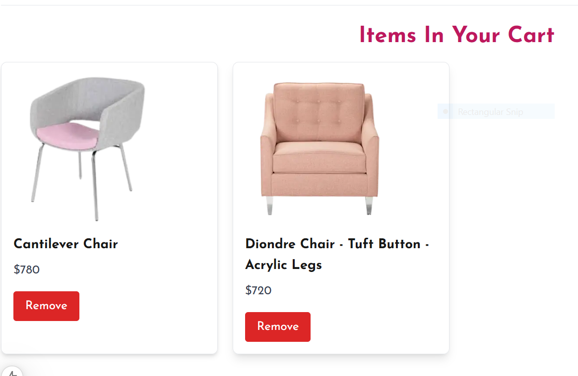

\*Footer Component:

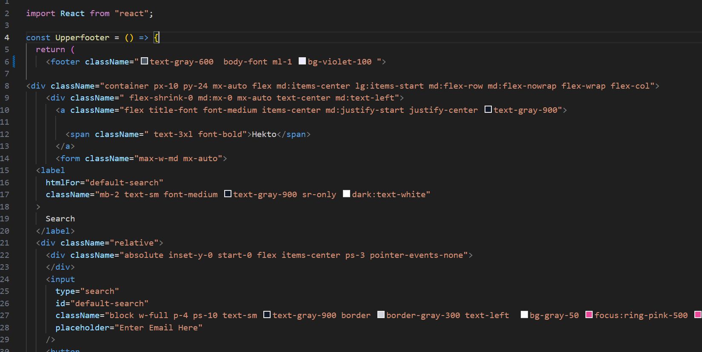

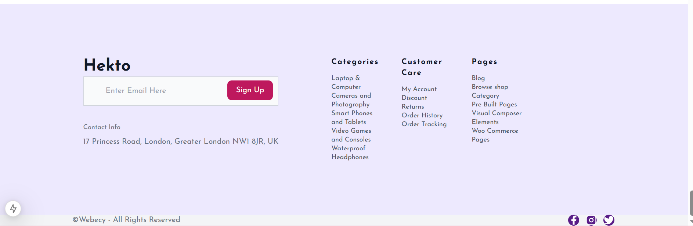

\*Header Component:

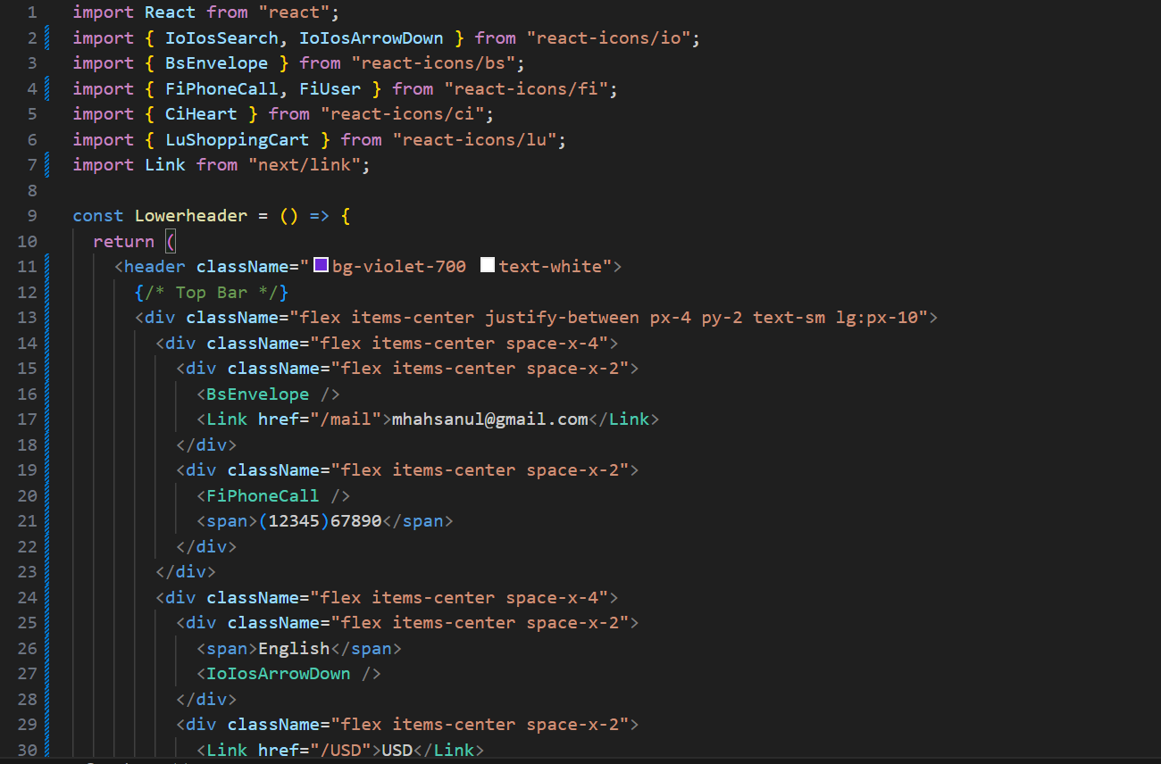



\*Login Details:

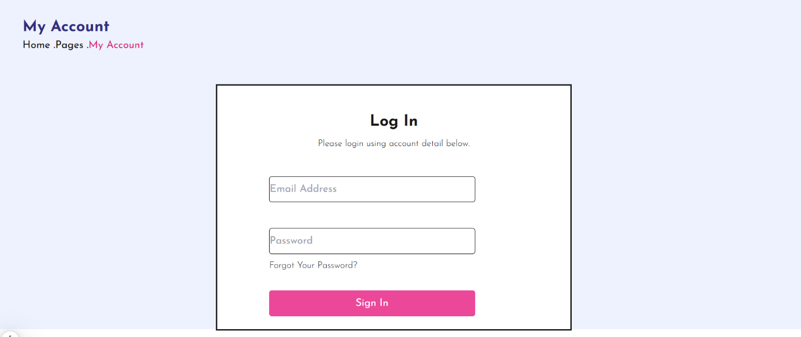

\*Fetching Data through Slug:

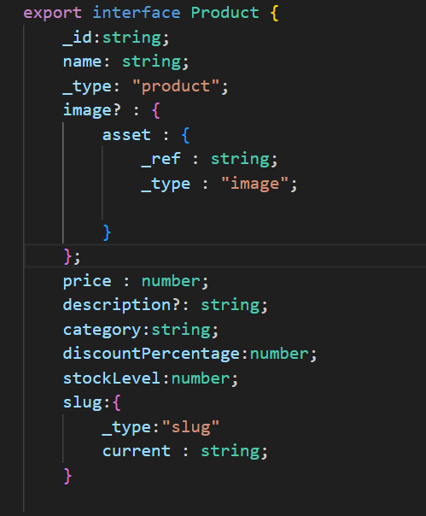

\*Generating Slug :

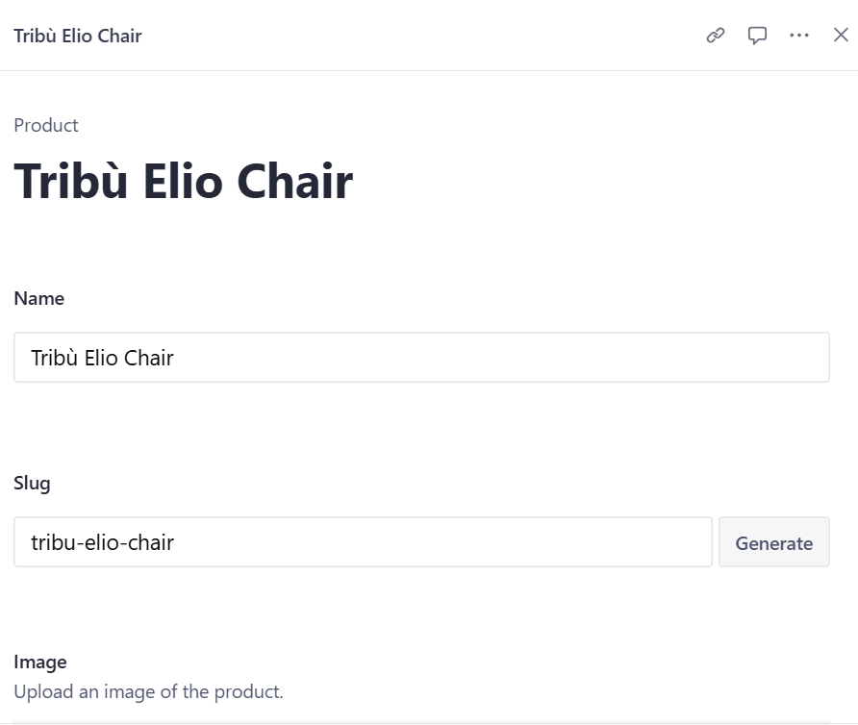

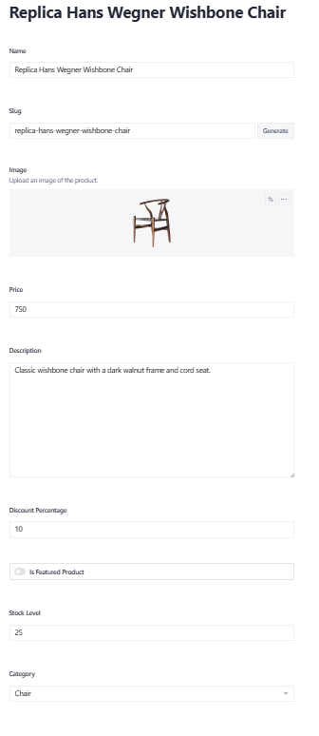

\*Check Out :

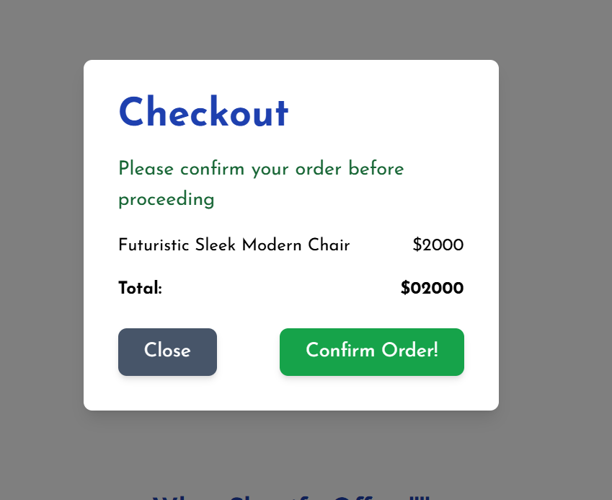

\*Confirmation Notification:

